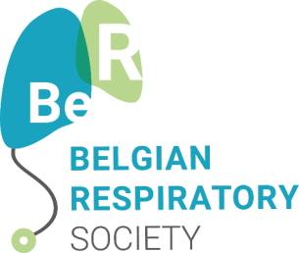

Scientific ASTRAZENECA AWARD 2023 in pneumology

APPLICATION FORM

This prize aims to stimulate Belgian scientific research in the field of pneumology.
This form must be returned by 6 November 2023 at the latest by e-mail to info@bers.be.

Details of the applicant

Last name :
First name :
Date of birth :
Telephone number :
Email address :

Diploma :
Date of graduation :

Profession :
Professional address :

I attach my CV to this form (max. 3 pages).

Project summary (in English – max 250 words – font size 11)

Reasons for the project (max ½ page)

Target(s) (max ½ page)

1.

2.

3.

4.

5.

Work plan (workload, deadline, schedule – max 2 pages)

Budget breakdown (max 1 page)

References (max 5)

1.

2.

3.

4.

5.

